Learn to ride

Learn to ride

High quality **western and English** ridding lessons focusing on safety and including instructions on horse care saddling a horse and other aspects of horsemanship

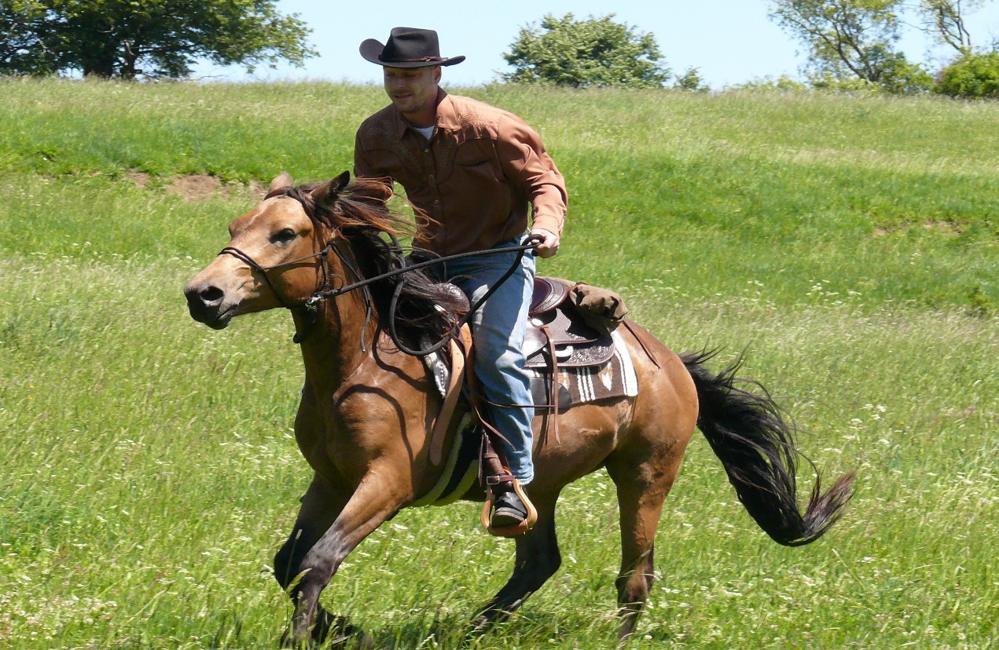

* Novice to advanced instruction for children and adults
* Indoor and outdoor arenas
* $40 per hour private lesson and $25 for group lessons

CALL TRI-VALLEY STABELS AT $$$ -2023 TODAY!